Free Lecture at the Cincinnati Museum Center
Wednesday, March 4, 2015 at 7:00 pm
“My Adventures with the Timber Rattlesnake in Ohio” presented by
Doug Wynn, Herpetologist, of The Ohio State University
Where: Reakirt Auditorium at Cincinnati Museum Center (Union Terminal). Walk straight through the Museum’s Rotunda towards the Omnimax, and the Reakirt Auditorium will be on your right.
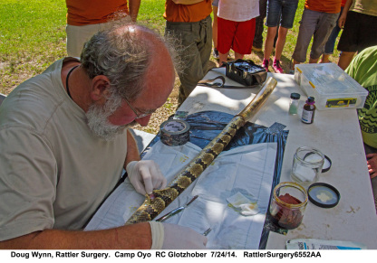
The Timber Rattlesnake is Ohio's largest venomous snake. Reaching a record length of 74 inches, it dwarfs the much smaller Eastern Massasauga rattlesnake, whose record length is 39.5 inches. The Timber Rattlesnake's natural behaviors and reproductive strategies have made the species highly vulnerable to human activities. In Ohio, it has undergone a drastic reduction in its distribution, resulting in viable populations occurring in only about four locations. Please join us to learn more about this endangered species and how controlling habitat destruction might be the only practical solution to preventing the Ohio Timber Rattlesnake from extinction.
Mr Wynn co-edited the authoritative 900 page “Amphibians of Ohio” published in 2013.
This Lecture is part of the Museum’s Free Insight Lecture Series
Cincinnati Museum Center at Union Terminal 1301 Western Avenue
Cincinnati, OH 45203
(513) 287-7000
Click here to register for this lecture or call 513-287-7001.

