2016–2017 Officers
President: Christine Hadley
445 Ward-Koebel Road
Oregonia, OH 45054
513 850-9585 christinehadley@earthlink.net

Vice President: Bob Bergstein
513 477-4438 bergstein123@gmail.com

Recording Secretary: Rob Repasky
513 505-5737
rrepasky1@yahoo.com

Treasurer & Membership:
Randy Johnson
treasurer@cincywildflower.org

Chairpersons
Field Trip Coordinator:
Christine Hadley 513 850-9585 christinehadley@earthlink.net

Programs & Publicity: Anita Buck
513 681-2574 aajbuck@earthlink.net

Plant Identification: Dan Boone
513 641-6572 morusman58@gmail.com

Hospitality: Jim Mason
937 239-5692 jmasonhmi@aol.com

Board members
March 2014–2017: Diana Boyd, Elizabeth Durrell, Judy Komorowski

March 2015–2018: Anita Buck, Christine Hadley, Randy Johnson

March 2016–2019: Bob Bergstein, Bill Edwards, Rob Repasky
General information
The Cincinnati Wild Flower Preservation Society is a nonprofit organization whose object is to promote the study and enjoyment of wild plant life, and the education of the membership and the public for the conservation of our native flora.

Membership levels & dues
Student $5.00 Active $12.00
Family $20.00 Contributing $25.00
Life $250.00
Make checks to: “Cincinnati Wild Flower Preservation Society.”
Please mail to:
Randy Johnson, Treasurer
947 Volterra Lane
Cincinnati, OH 45206

Meetings
Most Friday lectures are at Avon Woods Nature Center (a Cincinnati park), 4235 Paddock Road, Cincinnati 45229. Not visible from the road, the lodge is at the end of a long unlit drive through the west side of the Avon Field golf course, 0.9 mile south of the Norwood Lateral (SR #562) and 0.4 mile north of Reading Road.
Dinner meetings are held at the Northern Hills Fellowship, 460 Fleming Road, Cincinnati 45231.
All events are free.
Visitors and guests welcome!

Details of all our events at
www.cincywildflower.org

Cincinnati
Wild Flower

Preservation Society

Southwestern Ohio Chapter
of the
Ohio Native Plant Society

Founded 1917

“Enjoy: Do Not Destroy”

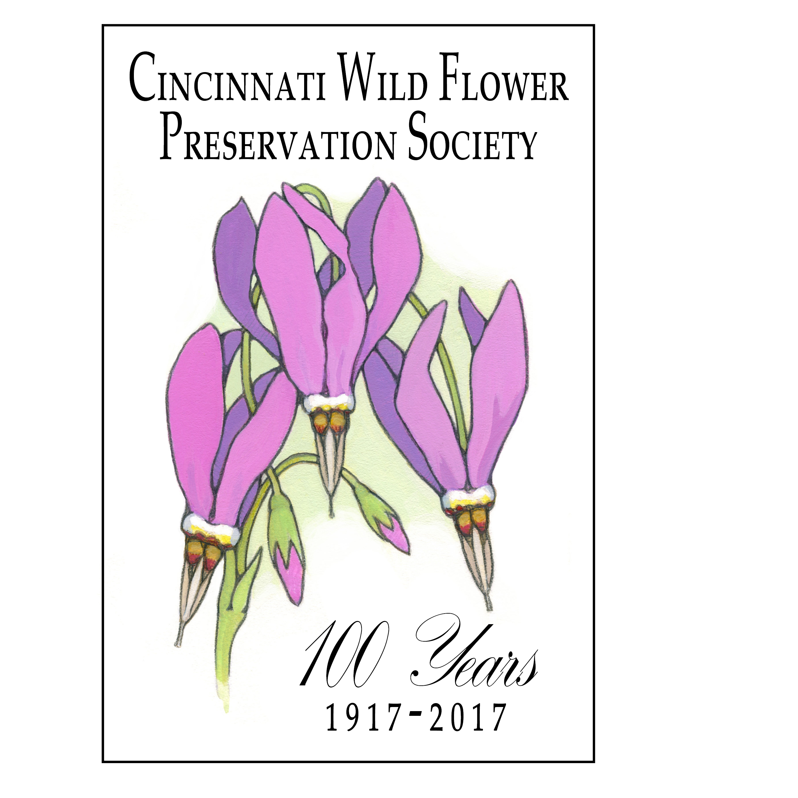

Program Schedule
2016–2017

